Determining insulin sensitivity from glucose tolerance tests in Iberian and Landrace pigs

J. M. Rodríguez-López1,a, M. Lachica1, L. González-Valero1 and I. Fernández-Fígares1

1Department of Physiology and Biochemistry of Animal Nutrition, Estación Experimental del Zaidín, CSIC, Profesor Albareda 1, 18008 Granada, Spain
aPresent address: Unité Transformations & Agro-Ressources (EA 7519), Institut Polytechnique UniLaSalle, Université d’Artois, 19 rue Pierre Waguet, 60026 Beauvais, France

Corresponding author: Ignacio Fernández-Fígares. Email: ifigares@eez.csic.es

Short title: Insulin sensitivity in Iberian and Landrace pigs

Abstract
As insulin sensitivity may help to explain divergences in growth and body composition between native and modern breeds, metabolic responses to glucose infusion were measured using an intra-arterial glucose tolerance test (IAGTT). Iberian (n = 4) and Landrace (n = 5) barrows (47.0 ± 1.2 kg BW), fitted with a permanent carotid artery catheter were injected with glucose (500 mg/kg BW) and blood samples collected at -10, 0, 5, 10, 15, 20, 25, 30, 45, 60, 90, 120 and 180 min following glucose infusion. Plasma samples were analysed for insulin, glucose, lactate, triglycerides, cholesterol, creatinine, albumin and urea. Insulin sensitivity indices were calculated and analysed. Mean plasma glucose, creatinine and cholesterol concentrations were lower (P < 0.01) in Iberian (14, 68 and 22%, respectively) compared with Landrace pigs during the IAGTT. However, mean plasma insulin, lactate, triglycerides and urea concentrations were greater (P < 0.001) in Iberian (50, 35, 18 and 23%, respectively) than in Landrace pigs. Iberian pigs had larger area under the curve (AUC) of insulin (P < 0.05) and lactate (P < 0.1), and smaller (P < 0.05) AUC for glucose 0-60 min compared with Landrace pigs. Indices for estimating insulin sensitivity in fasting conditions indicated improved β-cell function in Iberian compared with Landrace pigs, but no difference (P > 0.10) in calculated insulin sensitivity index was found after IAGTT between breeds. A time response (P < 0.05) was obtained for insulin, glucose and lactate so that maximum concentration was achieved 10 and 15 min post-infusion for insulin (Iberian and Landrace pigs, respectively), immediately post-infusion for glucose, and 20 min post-infusion for lactate, decreasing thereafter until basal levels. There was no time effect for the rest of metabolites evaluated. In conclusion, growing Iberian pigs challenged with an IAGTT showed changes in biochemical parameters and insulin response that may indicate an early stage of insulin resistance.

Keywords: insulin resistance, metabolism, obesity, fatty pigs, lean pigs

Implications
The pig has evolved as a complementary alternative research model to laboratory animals for obesity studies in humans. Obesity is characterized by an over-accumulation of body fat and is often linked to insulin resistance. The Iberian pig, a breed very much appreciated for their expensive cured products, is a candidate swine model with elevated capacity of fat deposition. We have shown that growing Iberian pigs also show features compatible with an installation of early insulin resistance

Introduction
The Iberian pig is a slow growing native breed of the Mediterranean basin with much greater whole body fat content than lean-type pigs (Nieto et al., 2002) and may be, considered as an obese pig breed (Barea et al., 2007; Torres-Rovira et al., 2011, 2012). Compared with conventional breeds, Iberian pigs show a lower efficiency of energy utilisation for protein deposition in the growing period (Barea et al., 2007). The greater relative viscera weight (Rivera-Ferre et al., 2005) and total heat production (González-Valero et al., 2016) associated in part with the greater rate of muscle protein turnover (Rivera-Ferre et al., 2005) in Iberian compared with lean-type pigs help to explain the low energy efficiency for growth. In fact, Rivera-Ferre et al. (2005) showed that muscle protein degradation was increased in Iberian pigs resulting in decreased muscle protein accretion compared with Landrace pigs. Interestingly, insulin resistance at the muscle level could explain an increased protein degradation (Wang et al., 2006) affecting overall protein accretion. In a previous study using balanced or lysine deficient diets at two CP levels (12% and 16% CP), Iberian pigs had greater fasting serum insulin concentration than Landrace pigs (Fernández-Fígares et al., 2007), suggesting the possibility of insulin resistance in Iberian pigs. We hypothesised that compared with modern lean breeds Iberian pigs have decreased insulin sensitivity, which could explain differences on growth, body composition and metabolic characteristics compared with modern breeds. The objective of the present study was to evaluate differences on insulin sensitivity between Iberian and Landrace pigs using an intra-arterial glucose tolerance test (IAGTT).

Material and methods
Animals
All procedures used in this study were approved by the Bioethical Committee of the Spanish National Research Council (CSIC, Spain), and the animals were cared for in accordance with the Royal Decree No. 1201/2005 (Spain). The experiment was performed with five Landrace and four Iberian (Silvela strain) barrows supplied by Granja El Arenal (Córdoba, Spain) and Sánchez Romero Carvajal (Jabugo S.A., Puerto de Santa María, Cádiz, Spain), respectively. The pigs were allowed ad libitum access to a standard diet (160 g CP/kg; 14 MJ metabolizable energy/kg DM) with free access to water in a controlled-environment room (21 ± 1.5°C). After acclimatization, each animal was surgically fitted with a chronic catheter in carotid artery following the procedure described previously (Rodríguez-López et al., 2013). After surgery, the pigs were fed at 2.4 × metabolizable energy for maintenance (444 kJ/kg^{0.75} BW; National Research Council (NRC) 1998) with the same standard diet. On the day of the experiment, pigs (46.0 ± 3.0 and 47.8 ± 3.6 kg BW, Iberian and Landrace, respectively, that is about 18 weeks and 14 weeks, respectively) were given an intra-arterial bolus (500 mg/kg BW) of glucose (50% sterile dextrose; glucosado 50% Braun, B. Braun Medical S.A., Rubi, Barcelona, Spain) over one min period after an overnight fast. The catheter was immediately flushed with 5 mL of sterile saline solution. Blood samples (5 mL) were collected at -10, 0 (20-30 seconds after the bolus of glucose and the saline solution), 5, 10, 15, 20, 25, 30, 45, 60, 90, 120 and 180 min following glucose infusion.

Biochemical analysis and calculations
Plasma was obtained by centrifugation (4ºC, 1820 x g for 30 min; Eppendorf 5810 R, Hamburg, Germany) and stored in aliquots at -20ºC until insulin and metabolites (glucose, lactate, triglycerides, cholesterol, creatinine, albumin and urea) were analysed. All samples were assayed in duplicate except for insulin which was assayed in triplicate.
Insulin was measured using commercially-available radioimmuno assay kit following the directions of the manufacturer (Millipore porcine insulin radioimmuno assay kit; Cat. PI-12K). Radioactivity in samples was measured using a gamma counter (Behring 1612; Nuclear Enterprises Ltd, Edinburgh, Scotland). Human insulin was used as standard, and the assay was validated for use in porcine plasma samples (Fernández-Fígares et al., 2007). The intra- and inter-assay CVs for plasma insulin were 4.4 and 9.1%, respectively.
Plasma glucose, lactate, triglycerides, cholesterol, creatinine, albumin and urea were measured colorimetrically using an automated Cobas Integra 400® analyser (Roche Diagnostics GmbH, Mannheim, Germany).
Responses of plasma insulin, glucose and lactate were evaluated separately by computing total area under the response curve (AUC) determined using trapezoidal geometry (GraphPad Prism, Version 5.02. San Diego, CA) for the time period indicated following intra-arterial glucose infusion (e.g. AUC0-5 stands for the integrated area between 0-5 min post-infusion, AUC0-10 between 0-10 min post-infusion, and so on, until AUC0-180). Basal levels per breed (at time -10 min) were used to calculate the corresponding AUC per metabolite. The rates of decline in plasma insulin and glucose concentrations for both breeds were calculated based on the slope in the linear portion of the response curve from 0 to 30 min after IAGTT challenge (Christoffersen et al., 2009). Results were then expressed as a fractional rate constant determined from the slope of the natural logarithm of plasma concentrations vs. time (Shipley and Clark, 1972; cited by (Gopinath and Etherton, 1989). The fractional turnover rates (k), or disappearance rates, of plasma insulin and glucose (%/min) were calculated using the relationship (Kaneko et al., 2008):
k = (Ln1 - Ln2)/(T2 - T1)
where Ln1 and Ln2 are the natural logarithms of plasma insulin concentration, (µU/mL, (or glucose concentration, mM) concentrations at times T1 (0 min) and T2 (30 min), respectively.
From the k value, the half-life, T_{½} (min), may be calculated as:
T_{½} = 100 x 0.693/k
For insulin sensitivity, indices used in human medicine were used.
The so-called homeostasis model assessment (HOMA; Matthews et al., 1985) was calculated for estimating insulin resistance (HOMA-IR) and β-cell function (HOMA-%B) at fasting conditions, as follows:
HOMA-IR: fasting plasma insulin (µU/mL) × fasting plasma glucose (mM)/22.5
HOMA-%B: (20 × fasting plasma insulin (µU/mL))/(fasting plasma glucose (mM) - 3.5)
It is assumed that non-insulin-resistant individuals have 100% β-cell function and an insulin resistance of 1.
The quantitative insulin sensitivity check index (QUICKI; Katz et al., 2000) was computed as:
1/[Ln(I₀) + Ln(G₀)]
where I₀ is the fasting insulin (μU/mL), and G₀ is the fasting glucose (mg/dl).
Finally, the insulin sensitivity index (CSI; Tura et al., 2010) was calculated as:
CSI = K_{G}/(ΔAUC_{INS}/T)
where K_{G} is the slope of Ln glucose in the linear portion of the response curve, ΔAUC_{INS} is the AUC of insulin above basal value, and T is the time interval (between 0 and 30 min) when K_{G} and ΔAUC_{INS} are calculated.

Statistical analyses
The number of animals was calculated using the G*Power software (Heinrich-Heine-Universität Düsseldorf; (Faul et al., 2007). Accepting an alpha risk of 0.05 and a beta risk of 0.2 in a two-sided test, 5 subjects are necessary in first group and 5 in the second to recognize as statistically significant a difference greater than or equal to 12 µU/ml on insulin concentration and a common standard deviation of 6.3 µU/ml based on previous studies (Fernández-Fígares et al., 2007). A total of 5 pigs per treatment was also used by others (e.g. Stoll et al., 1999). However, one Iberian pig lost the arterial catheter during the recovery period after surgery and only four Iberian pigs could be used.
Plasma metabolites were evaluated using a mixed ANOVA with repeated measures (Version 9.4; PROC MIXED, SAS Institute Inc., Cary, NC, USA) with the fixed effects of breed, time of sampling and their interaction in the model statement. The pig was considered a random effect. First-order ante dependence covariance ANTE(1) was used, which allows unequal variances over time and unequal correlations and covariance among different pairs of measurements. Plasma concentration differences between breeds at each sampling time were analysed by the pdiff (piecewise differentiable) option.
Assumptions that are required for an ANOVA were tested following the protocol from Zuur et al. (2010). Homogeneity of variance was assured by applying the Levene’s-Test. No transformation was required. Least square means and pooled SEM are presented. Differences were considered significant at P < 0.05 and trends approaching significance were considered for 0.05 < P < 0.10.

Results
Fasting plasma insulin was greater in Iberian compared with Landrace pigs (15.6 and 8.10 µU/mL, respectively; sem=1.55, P < 0.05) whereas fasting plasma glucose was similar for both breeds (4.68 and 5.85 mmol/L for Iberian and Landrace pigs, respectively; sem=0.92, P > 0.10). No differences between breeds were found in fasting plasma albumin (Iberian 0.50 and Landrace 0.54 µM), urea (Iberian 3.3 and Landrace 3.0 mM), cholesterol (Iberian 1.46 and Landrace 1.79 mM) and triglycerides (Iberian 0.28 and Landrace 0.22 mM). On the other hand plasma fasting creatinine was lower in Iberian compared to Landrace (54 and 102 µM, respectively; P < 0.01).
Average plasma metabolites and insulin concentrations after the IAGTT are shown in Table 1. Mean plasma glucose, cholesterol and creatinine concentrations were lower in Iberian (14, 22 and 68%, respectively; P < 0.05) compared with Landrace pigs. However, mean plasma insulin, lactate, triglycerides and urea concentrations were greater in Iberian (50, 35, 18 and 23%, respectively; 0.01 < P < 0.001) than in Landrace pigs. No differences (P > 0.1) were found between breeds for albumin levels.
Only plasma insulin (Figure 1), glucose (Figure 2) and lactate (Figure 3) concentrations changed throughout time (P < 0.001; Table1) after the IAGTT.
An interaction between breed and time was found for plasma insulin, such that concentration of insulin was greater in Iberian pigs from -10 to 15 min and from 90-180 min (P < 0.05, with P < 0.1 at times 0 and 90 min) and lower at 25 min (P < 0.1; Figure 1). In both breeds, plasma insulin levels increased 7-fold, reaching a peak concentration 10 and 15 min after glucose infusion for Iberian (113.6 ± 7.1 µU/mL) and Landrace (55.7 ± 6.4 µU/mL) pigs, respectively. Insulin remained well above fasting levels until 20 and 45 min after glucose infusion for Iberian and Landrace pigs, respectively; thereafter insulin levels rapidly decreased until fasting levels were attained. Fractional turnover rate tended to increase in Iberian compared with Landrace pigs (6.2 and 4.7 ± 0.46%/min, respectively; 0.05 < P < 0.1) while half-life tended to decrease (11.3 and 15.2 ± 1.30 min for Iberian and Landrace pigs, respectively; 0.05 < P < 0.1).
Glucose peaked (Figure 2) immediately after glucose infusion reaching a value of 19.6 mmol/L and 21.2 mmol/L for Iberian and Landrace pigs, respectively. Subsequently, glucose concentration gradually decreased to values below fasting levels after 25 min and 30 min, respectively for Iberian and Landrace pigs. The lowest plasma glucose concentration (glucose nadir) was found at 45 min (2.95 mmol/L and 3.70 mmol/L for Iberian and Landrace pigs, respectively). After glucose nadir, glucose concentration gradually increased again to reach values comparable to fasting levels at 180 min. No differences were found between breeds for glucose fractional turnover rate (4.1 and 3.3 ± 0.37%/min for Iberian and Landrace pigs, respectively; P > 0.10) or glucose half-life (17.1 and 22.1 ± 2.67 min for Iberian and Landrace pigs, respectively; P > 0.10).
Lactate increased after the IAGTT, peaked at 20 min for both breeds and declined progressively until reaching basal concentrations at 180 min (Figure 3).
The AUC values for each sampling time of insulin, glucose and lactate are shown in Figure 4, 5 and 6, respectively. Insulin AUC was greater (P < 0.05) for Iberian compared with Landrace pigs at all times. Conversely, glucose AUC between 0-15, 0-20, 0-25, 0-30, 0-45 and 0-60 min were lower (P < 0.05) for Iberian than Landrace pigs. Glucose AUC tended to be lower (0.05 < P < 0.10) between 0-10, 0-90 and 0-120 min. No differences (P < 0.05) in glucose AUC was found between 0-5, 0-150 and 0-180 min. Plasma lactate AUC was greater (P < 0.05) for Iberian pigs for 0-10 and 0-15 min and tended to be greater (0.05 < P < 0.10) for 0-5, 0-20, 0-25, 0-90, 0-120, 0-150 and 0-180 min after glucose infusion.
Indices of insulin sensitivity are shown in Table 2. The QUICKI index decreased (P < 0.05) while HOMA-%B index increased (P < 0.01) in Iberian compared with Landrace pigs. No differences (P > 0.10) were found for HOMA-IR and CSI.

Discussion
The IAGTT method allowed the comparison of the insulin responsiveness of an obese (Iberian) and a lean (Landrace) pig breed. It has previously been shown that Iberian pigs are fatty pigs with slow growth rate compared to modern breeds (Nieto et al., 2012). As arterial blood represents the metabolites concentration to which the tissues are exposed (Brouns et al., 2005), chronic catheters were inserted in carotid artery for glucose infusion and blood sampling.
In the current study we have shown increased fasting plasma insulin and insulin response (higher plasma concentrations and AUC) after glucose infusion in Iberian compared with Landrace pigs (18 and 14 weeks of age, respectively). Greater postprandial serum levels of insulin have been described in 20 kg Iberian (11 weeks of age) compared to Landrace after glucose infusion (Fernández-Fígares et al., 2007), and in 11kg Ossabaw (obese; 10 weeks of age) compared to 16.5 kg Yorkshire (10 weeks of age) pigs (Wangsness et al., 1981). However, other comparative studies using a standard diet found increased insulin secretion in 75-120 kg Large White boars than in 40-75 kg Meishan boars (obese breed) at 20 and 52 weeks of age, respectively (Weiler et al., 1998). The limited growth and development of slow growing pigs could result at least partly from disturbances in insulin secretion and/or in insulin binding, leading to insulin sensitivity, because most cells of the body require insulin for adequate uptake of glucose and amino acids (Claus and Weiler, 1994). If the concentration of insulin is compared among animals of different breeds, the sensitivity of each breed to insulin should be considered. In this study we were also interested in other key metabolites which could provide additional information concerning insulin sensitivity in Iberian pigs.
After glucose infusion, glucose plasma concentration rapidly returns to preprandial values as shown in the present experiment, which indicates that exogenous glucose was efficiently metabolized, stored as glycogen, or both. As expected, when glucose was infused, plasma glucose levels were rapidly increased and a subsequent insulin response was observed. The elevated insulin lowered plasma glucose below fasting values within 20 and 25 min for Iberian and Landrace pigs, respectively, and insulin levels returned to baseline as plasma glucose declined. In our study, glucose concentration and glucose AUC during the IAGTT were lower in Iberian compared with Landrace pigs, with no differences in fasting plasma glucose, maybe due to the limited number of pigs. When interpreting the individual glucose curves, a monophasic pattern was identified for both breeds. The lower glucose AUC of Iberian pigs (-19% on average) may be related to the greater insulin AUC (+33% on average), a common pattern in many models of obesity (Kay et al., 2001). However, the reasons for the unequal physiological response between breeds are not well understood and must be discussed.
As it has been proved that the energy needs of portal-drained viscera are fulfilled by the oxidation of glucose, glutamate, and glutamine in pigs (Stoll et al., 1999), a larger gastrointestinal tract of Iberian pigs compared to Landrace (Rivera-Ferre et al., 2005) is in line with the decreased AUC of glucose reported in our experiment.
However, despite the larger size of the gastrointestinal tract and lower portal blood flow (González-Valero et al., 2016) of Iberian compared with Landrace pigs, no differences on net portal flux of glucose after ingestion of the same diet were found (Rodríguez-López et al., 2013). Differences on insulin stimulated glucose transport at portal-drained viscera level may help to explain these results. Iberian have lower glucose concentrations than Landrace pigs after an intravenous adrenaline challenge (Fernández-Fígares et al., 2016), suggesting a decreased response of Iberian pigs to sympathetic nervous system stimuli which is in line with the lower glucose AUC reported here.
Lactate appearance after an intravenous glucose test is positively associated with insulin sensitivity in humans (Lovejoy et al., 1992), as it is related to lactate production by insulin sensitive tissues (mainly muscle and fat). Because only limited amounts of lactate are produced by muscle after glucose loading (Ykijarvinen et al., 1990), the source of lactate appearance should predominantly be adipose tissue (Lovejoy et al., 1992), with a large capacity to convert glucose to lactate (Marin et al., 1987). We report here a delay of 20 min in plasma lactate elevation relative to glucose peak following IAGTT, which may reflect the time lag in adipose tissue uptake of glucose and subsequent lactate production under the stimulation of insulin. Compared with Landrace, the increased lactate AUC in Iberian pigs after the IAGTT could therefore be a consequence of a larger adipose tissue (Nieto et al., 2002) instead of greater insulin sensitivity. On the other hand, insulin resistance was associated with elevated basal lactate levels in obese humans (Lovejoy et al., 1990), so increased basal lactate concentrations in Iberian pigs (1.040 vs. 0.730 mmol/L; sem=0.063) could also indicate insulin resistance or reduced insulin sensitivity. Although inhibition of insulin action on glycogenolysis in fasting conditions may lead to increased glucose release from glycogen and subsequent conversion of glucose to lactate, there is no direct evidence of this. There is indirect evidence, though, that elevated lactate levels reflect a glucose sparing effect (decreased glucose utilisation) in muscle (Pearce and Connett, 1980).
Obesity is frequently associated with different degrees of dyslipidemia manifested as increased triglyceridemia and low HDL-cholesterol. In our experiment, we found lower plasma cholesterol but greater plasma triglycerides concentration in Iberian compared with Landrace pigs, although we did not separate LDL and HDL fractions. Reduced total cholesterol concentration could be due to reduced hepatic insulin sensitivity as insulin stimulates cholesterol synthesis (Nelson and Cox, 2017). In any case the cholesterolemia for both breeds in the present experiment was in the lower range of published values (Fernández-Fígares et al., 2007) and it cannot be considered that Landrace pigs were hypercholesterolemic.
Previous studies in our lab have shown the low genetic potential of growing Iberian pigs for muscle protein deposition in comparison to lean breeds (Nieto et al., 2002), possibly due to the greater muscle protein degradation and turnover of the former (Rivera-Ferre et al., 2005). In line with this, plasma urea level (an indirect protein degradation indicator) was in the present study 23% greater in Iberian compared with Landrace pigs. Differences on circulating insulin or the capacity of insulin release between breeds may explain differences in lean tissue deposition, as insulin has an important role in skeletal muscle metabolism (Wang et al., 2006). In obese db/db mice (a model of insulin deficiency) higher muscle protein degradation in comparison with control mice (normal plasma insulin concentration) was reported; the authors concluded that insulin resistance was associated with accelerated muscle protein degradation (Wang et al., 2006). The elevated protein degradation reported in Iberian compared with Landrace pigs (Rivera-Ferre et al., 2005) suggests the possibility of insulin resistance at this level. The lower plasma creatinine level (indicator of muscle mass) found in this study for Iberian pigs, is in accordance with previous studies (Fernández-Fígares et al., 2007) and also with the low muscle protein deposition and muscle size described previously (Nieto et al., 2002; Rivera-Ferre et al., 2005). As insulin resistance is associated with decreased muscle mass, plasma creatinine levels can also be used as an indicator of insulin signalling disorders as reported by Kashima et al. (2017) in humans. Further research regarding amino acid concentration after an IAGTT may help to explain differences in the effect of insulin on muscle protein metabolism between breeds.
When insulin sensitivity indices used in human medicine were applied to the conditions of the present experiment, QUICKI and HOMA-%B were more sensitive detecting differences between breeds. Indeed, QUICKI index decreased in Iberian compared with Landrace pigs, pointing out an incipient insulin sensitivity impairment in fasting Iberian pigs. Similarly, reduced QUICKI index (0.5 vs. 0.6) was found in Bama miniature pigs fed a high sucrose high fat diet compared with a control diet, respectively (Liu et al., 2017). The QUICKI index has been shown to provide reasonable approximations of insulin efficiency in minipigs (Christoffersen et al., 2009).
When we used the homeostasis model assessment (HOMA), differences on hepatic insulin resistance (HOMA-IR index) were negligible between breeds (3.3 and 2.3 for Iberian and Landrace, respectively; P>0.10). However, Iberian had improved β-cell function compared with Landrace pigs according to HOMA-%B index (267 and 100 for Iberian and Landrace, respectively; P<0.01), which may be due to enhanced sensitivity of the β-cells to glucose during the fasting period. As a consequence, β-cell insulin synthesis in Iberian pigs increased in accordance with the increased insulin release after the glucose tolerance test and the elevated basal insulin concentrations reported for Iberian pigs. This is consistent with decreased quantitative insulin sensitivity check index in Iberian pigs compared to Landrace (0.31 and 0.33 for Iberian and Landrace, respectively; P<0.05).
Previous studies from our lab indicate that growing Iberian pigs are prone to insulin resistance compared with modern breeds as denoted by increased hepatic gluconeogenesis (González-Valero et al., 2014), greater plasma free fatty acid concentration (Fernández-Fígares et al., 2016) and lower plasma creatinine and QUICKI index (Fernández-Fígares et al., 2007). Additionally, in this experiment we show greater HOMA-%B and increased plasma insulin and lactate concentrations after an IAGTT. The increased plasma insulin AUC after an IAGTT suggests insulin resistance in comparison to values obtained for lean pigs, although the concentration of glucose remained low which could indicate the absence of a peripheral insulin resistance. Although Iberian pigs may be considered an obese breed in terms of body composition (Nieto et al., 2002; Barea et al., 2007), insulin resistance mechanisms have not yet been fully established at the development stage of the pigs in this experiment. Insulin resistance and impaired glucose tolerance has been shown in Iberian sows (2.5 years old) ad libitum fed a saturated fat enriched diet for three months (Torres-Rovira et al., 2012). Although our results support the existence of an insulin resistance or a decreased insulin sensitivity in growing Iberian pigs, caution should be taken because of the reduced number of pigs used. The utilization of the hyperinsulinemic euglycemic clamp, the most definitive approach to determine whole-body insulin action should provide conclusive evidence regarding the establishment of insulin resistance in growing Iberian pigs.

Acknowledgements
The authors thank the company Sánchez Romero Carvajal (Jabugo S.A., Puerto de Santa María, Spain) for their helpful collaboration, Dr Luis Lara for statistical advice and Dr Thomas J. Caperna for critically reading the manuscript. This research was supported by grant AGL2006-5937 from the Ministry of Science and Education of Spain.

Declaration of interest
There are no conflicts of interest.

Ethics statement
The procedures used in this study were approved by the Bioethical Committee of the Spanish National Research Council (CSIC, Spain), and the animals were cared for in accordance with the Royal Decree No. 1201/2005 (Spain).

Software and data repository resources
Data and models are not deposited in an official repository.

References

Barea R, Nieto R and Aguilera JF 2007. Effects of the dietary protein content and the feeding level on protein and energy metabolism in Iberian pigs growing from 50 to 100 kg body weight. Animal 1, 357-365.
Brouns F, Bjorck I, Frayn KN, Gibbs AL, Lang V, Slama G and Wolever TMS 2005. Glycaemic index methodology. Nutrition research reviews 18, 145-171.
Christoffersen B, Ribel U, Raun K, Golozoubova V and Pacini G 2009. Evaluation of different methods for assessment of insulin sensitivity in Gottingen minipigs: introduction of a new, simpler method. American Journal of Physiology-Regulatory Integrative and Comparative Physiology 297, R1195-R1201.
Claus R and Weiler U 1994. Endocrine regulation of growth and metabolism in the pig - a review. Livestock Production Science 37, 245-260.
Faul, F., E. Erdfelder, A.-G. Lang, and A. Buchner. 2007. G*Power 3: A flexible statistical power analysis program for the social, behavioral, and biomedical sciences. Behavior Research Methods 39: 175-191.
Fernández-Fígares I, Lachica M, Nieto R, Rivera-Ferre MG and Aguilera JF 2007. Serum profile of metabolites and hormones in obese (Iberian) and lean (Landrace) growing gilts fed balanced or lysine deficient diets. Livestock Science 110, 73-81.
Fernández-Fígares I, Rodríguez-López JM, González-Valero L and Lachica M 2016. Metabolic responses to adrenaline challenge in Iberian compared to Landrace pigs. In 9th International Symposium on Mediterranean Pig, Portalegre, Portugal, p. 67.
González-Valero L, Rodríguez-López JM, Lachica M and Fernández-Fígares I 2014. Metabolic differences in hepatocytes of obese and lean pigs. Animal 8, 1873-1880.
González-Valero L, Rodríguez-López JM, Lachica M and Fernández-Fígares I 2016. Contribution of portal-drained viscera to heat production in Iberian gilts fed a low protein diet: comparison to Landrace. Journal of the Science of Food and Agriculture 96, 1202-1208.
Gopinath, R., and T. D. Etherton. 1989. Effects of porcine growth-hormone on glucose-metabolism of pigs .2. Glucose-tolerance, peripheral tissue insulin sensitivity and glucose kinetics. Journal of Animal Science 67: 689-697.
Kaneko JJ. Carbohydrate metabolism and its diseases. In: , 6th ed.; Kaneko JJ, Harvey JW and Bruss ML Eds.; Academic Press, London, UK, 2008; pp. 45-80.
Kashima S, Inoue K, Matsumoto M and Akimoto K 2017. Low serum creatinine is a type 2 diabetes risk factor in men and women: The Yuport Health Checkup Center cohort study. Diabetes and Metabolism 43, 460-464.
Katz A, Nambi S, Mather K, Baron A, Follmann D, Sullivan G and Quon M 2000. Quantitative Insulin Sensitivity Check Index: A Simple, Accurate Method for Assessing Insulin Sensitivity In Humans. The Journal of clinical endocrinology and metabolism 85, 2402-2410.
Kay JP, Alemzadeh R, Langley G, D'Angelo L, Smith P and Holshouser S. 2001. Beneficial effects of metformin in normoglycemic morbidly obese adolescents. Metabolism-Clinical and Experimental 50: 1457-1461.
Liu YQ, Yuan JF, Xiang L, Zhao YQ, Niu MM, Dai X and Chen H 2017. A high sucrose and high fat diet induced the development of insulin resistance in the skeletal muscle of Bama miniature pigs through the Akt/GLUT4 pathway. Experimental Animals 66, 387-395.
Lovejoy J, Mellen B and Digirolamo M 1990. Lactate generation following glucose-ingestion - relation to obesity, carbohydrate-tolerance and insulin sensitivity. International Journal of Obesity 14, 843-855.
Lovejoy J, Newby FD, Gebhart SSP and Digirolamo M 1992. Insulin resistance in obesity is associated with elevated basal lactate levels and diminished lactate appearance following intravenous glucose and insulin. Metabolism-Clinical and Experimental 41, 22-27.
Marin P, Rebuffescrive M, Smith U and Bjorntorp P 1987. Glucose-uptake in human adipose-tissue. Metabolism-Clinical and Experimental 36, 1154-1160.
Matthews DR, Hosker JP, Rudenski AS, Naylor BA, Treacher DF and Turner RC 1985. Homeostasis model assessment - insulin resistance and beta-cell function from fasting plasma-glucose and insulin concentrations in man. Diabetologia 28, 412-419.
Nelson DL and Cox MM 2017. Cholesterol, Steroids, and Isoprenoids: Biosynthesis, Regulation, and Transport. In Lehninger principles of biochemistry. 7th ed.; W.H. Freeman; New York, NY; pp.816-832.
National Research Council (NRC) 1998. Nutrient requirements of swine,10th edition. National Academy Press, Washington, DC.
Nieto R, Lara L, Barea R, Garcia-Valverde R, Aguinaga MA, Conde-Aguilera JA and Aguilera JF 2012. Response analysis of the Iberian pig growing from birth to 150 kg body weight to changes in protein and energy supply. Journal of Animal Science 90, 3809-3820.
Nieto R, Miranda A, Garcia MA and Aguilera JF 2002. The effect of dietary protein content and feeding level on the rate of protein deposition and energy utilization in growing Iberian pigs from 15 to 50 kg body weight. British Journal of Nutrition 88, 39-49.
Pearce FJ and Connett RJ 1980. Effect of lactate and palmitate on substrate utilization of isolated rat soleus. American Journal of Physiology 238, C149-C159.
Rivera-Ferre MG, Aguilera JF and Nieto R 2005. Muscle fractional protein synthesis is higher in Iberian than in landrace growing pigs fed adequate or lysine-deficient diets. Journal of Nutrition 135, 469-478.
RodrÍguez-López JM, Lachica M, González-Valero L and Fernández-Fígares I 2013. Approaches for quantifying gastrointestinal nutrient absorption and metabolism in a native and a modern pig breed. Journal of Agricultural Science 151, 434-443.
Shipley RA and Clark RE 1972. Tracer methods for In vivo kinetics. Theory and applications. Academic Press, New York.
Stoll B, Burrin DG, Henry J, Yu H, Jahoor F and Reeds PJ 1999. Substrate oxidation by the portal drained viscera of fed piglets. American Journal of Physiology-Endocrinology and Metabolism 277, E168-E175.
Torres-Rovira L, Astiz S, Caro A, Lopez-Bote C, Ovilo C, Pallares P, Perez-Solana ML, Sanchez-Sanchez R and Gonzalez-Bulnes A 2012. Diet-Induced Swine Model with Obesity/Leptin Resistance for the Study of Metabolic Syndrome and Type 2 Diabetes. Scientific World Journal 2012:510149.
Torres-Rovira L, Pallares P, Vigo E, Gonzalez-Anover P, Sanchez-Sanchez R, Mallo F and Gonzalez-Bulnes A . 2011. Plasma Leptin, Ghrelin and Indexes of Glucose and Lipid Metabolism in Relation to the Appearance of Post-Weaning Oestrus in Mediterranean Obese Sows (Iberian Pig). Reproduction in Domestic Animals 46: 558-560.
Tura A, Sbrignadello S, Succurro E, Groop L, Sesti G and Pacini G 2010. An empirical index of insulin sensitivity from short IVGTT: validation against the minimal model and glucose clamp indices in patients with different clinical characteristics. Diabetologia 53, 144-152.
Wang X, Hu Z, Hu J, Du J and Mitch W 2006. Insulin Resistance Accelerates Muscle Protein Degradation: Activation of the Ubiquitin-Proteasome Pathway by Defects in Muscle Cell Signaling. Endocrinology 147, 4160-4168.
Wangsness PJ, Acker WA, Burdette JH, Krabill LF and Vasilatos R 1981. Effect of fasting on hormones and metabolites in plasma of fast-growing, lean and slow-growing obese pigs. Journal of Animal Science 52, 69-74.
Weiler U, Claus R, Schnoebelen Combes S and Louveau I 1998. Influence of age and genotype on endocrine parameters and growth performance: a comparative study in Wild boars, Meishan and Large White boars. Livestock Production Science 54, 21-31.
Ykijarvinen H, Bogardus C and Foley JE 1990. Regulation of plasma lactate concentration in resting human-subjects. Metabolism-Clinical and Experimental 39, 859-864.
Zuur AF, Ieno EN and Elphick CS 2010. A protocol for data exploration to avoid common statistical problems. Methods in Ecology and Evolution 1, 3-14.

Table 1 Average plasma metabolites and insulin concentrations in Iberian (n = 4) and Landrace (n = 5) pigs during an intra-arterial glucose tolerance test (500 mg/kg BW, 0-180 min)
 | Breed |  |  | P-value1
 | Iberian | Landrace | SEM | Breed | Time | Breed × Time
Insulin (µU/mL) | 41 | 27 | 1.9 | *** | *** | ***
Glucose (mmol/L) | 6.8 | 7.7 | 0.26 | ** | *** | 0.257
Lactate (mmol/L) | 1.3 | 1.0 | 0.039 | *** | *** | 0.989
Triglycerides (mmol/L) | 0.28 | 0.24 | 0.009 | ** | 0.474 | 0.954
Cholesterol (mmol/L) | 1.5 | 1.8 | 0.033 | *** | 0.934 | 0.999
Creatinine (µmol/L) | 54 | 90 | 1.2 | ** | 0.722 | 0.955
Albumin (mmol/L) | 0.48 | 0.50 | 0.009 | 0.131 | 0.992 | 0.999
Urea (mmol/L) | 3.0 | 2.4 | 0.102 | *** | 0.779 | 0.999
¹ns = non-significant; **P < 0.01; ***P < 0.001.

Table 2 Indices of glucose tolerance and insulin sensitivity in Iberian (n = 4) and Landrace (n = 5) pigs subjected to an intra-arterial glucose tolerance test (500 mg/kg BW ⁾¹
 | Iberian | Landrace | SEM | P-value2
QUICKI | 0.31 | 0.33 | 0.007 | *
HOMA-IR | 3.3 | 2.3 | 0.58 | 0.205
HOMA-%B | 267 | 100 | 25.6 | **
CSI (×10⁻⁴) | -12 | -13 | 1.8 | 0.845
¹QUICKI: quantitative insulin sensitivity check index; HOMA-IR: homeostasis model assessment for estimating insulin resistance; HOMA-%B: homeostasis model assessment for estimating β-cell function; CSI: calculated insulin sensitivity index.
²ns = non-significant; *P < 0.05; **P < 0.01.

Figure 1 Plasma insulin concentrations before and after intra-arterial glucose tolerance test (500 mg/kg BW) in growing Iberian (n = 4) and Landrace (n = 5) pigs^{1, 2}.
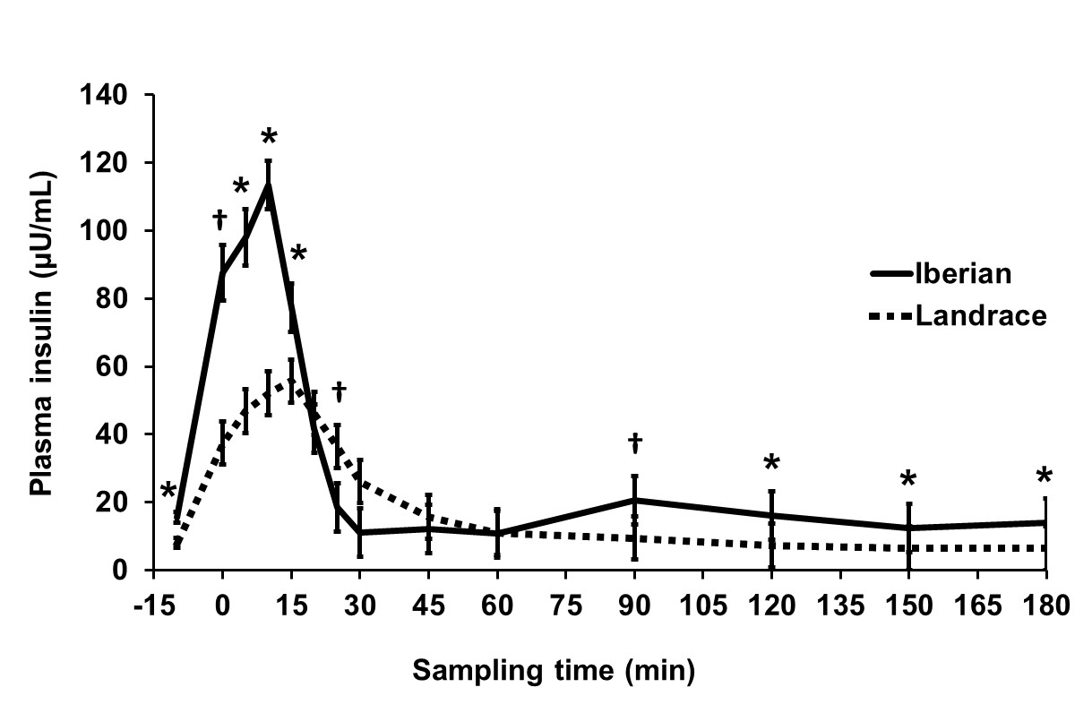
¹Significant differences in plasma insulin concentration for each time point expressed as: †0.05 < P < 0.1, *P < 0.05.
²Concentrations at time 0 correspond to 20-30 s after glucose bolus injection.

Figure 2 Plasma glucose concentration before and after intra-arterial glucose tolerance test (500 mg/kg BW) in growing Iberian (n = 4) and Landrace (n = 5) pigs^{1, 2}.

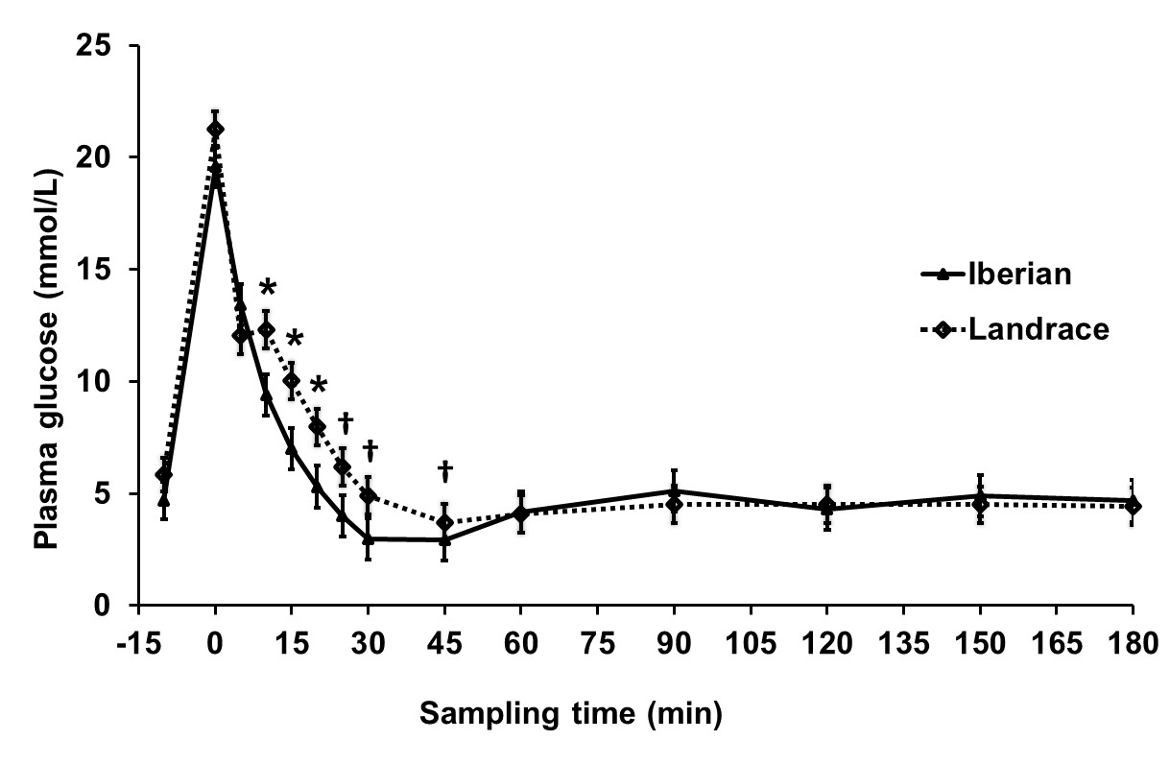
¹Significant differences in plasma glucose concentration for each time point expressed as: †0.05 < P < 0.1, *P < 0.05.
²Concentrations at time 0 correspond to 20-30 s after glucose bolus injection.

Figure 3 Plasma lactate concentration before and after intra-arterial glucose tolerance test (500 mg/kg BW) in growing Iberian (n = 4) and Landrace (n = 5) pigs^{1, 2}.

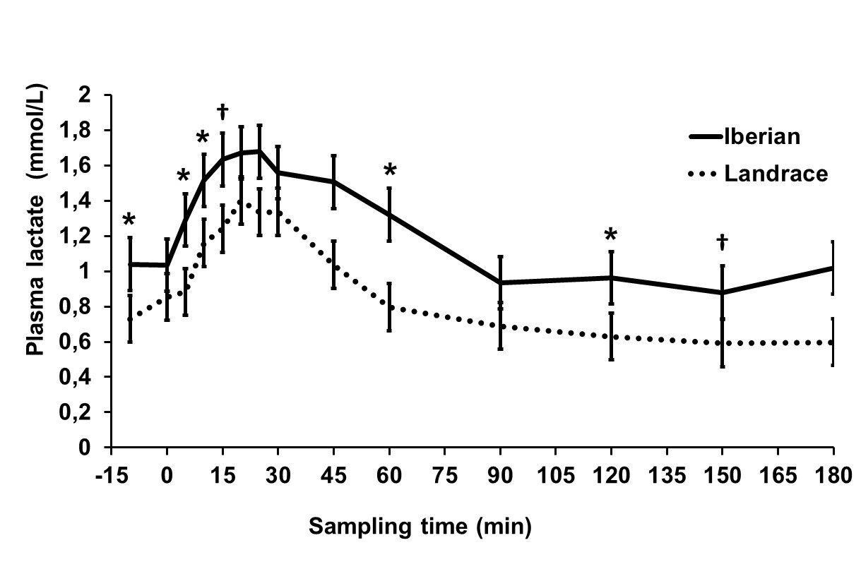
¹Significant differences in plasma lactate concentration for each time point expressed as: †0.05 < P < 0.1, *P < 0.05.
²Concentrations at time 0 correspond to 20-30 s after glucose bolus injection.

Figure 4 Area under the curve (AUC) of plasma insulin concentration during intra-arterial glucose tolerance test (500 mg/kg BW) between minute 0 and the time points indicated in growing Iberian (n = 4) and Landrace (n = 5) pigs¹.
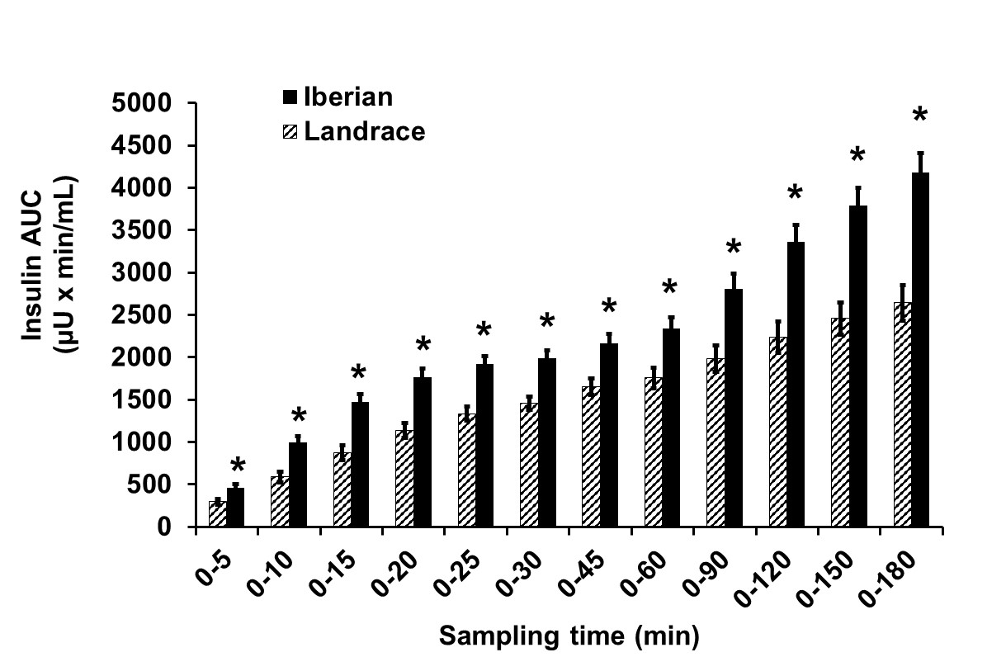
¹Differences between breeds: *P < 0.05.

Figure 5 Areas under the curve (AUC) of plasma glucose concentration during intra-arterial glucose tolerance test (500 mg/kg BW) between minute 0 and the time points indicated in growing Iberian (n = 4) and Landrace (n = 5) pigs¹.

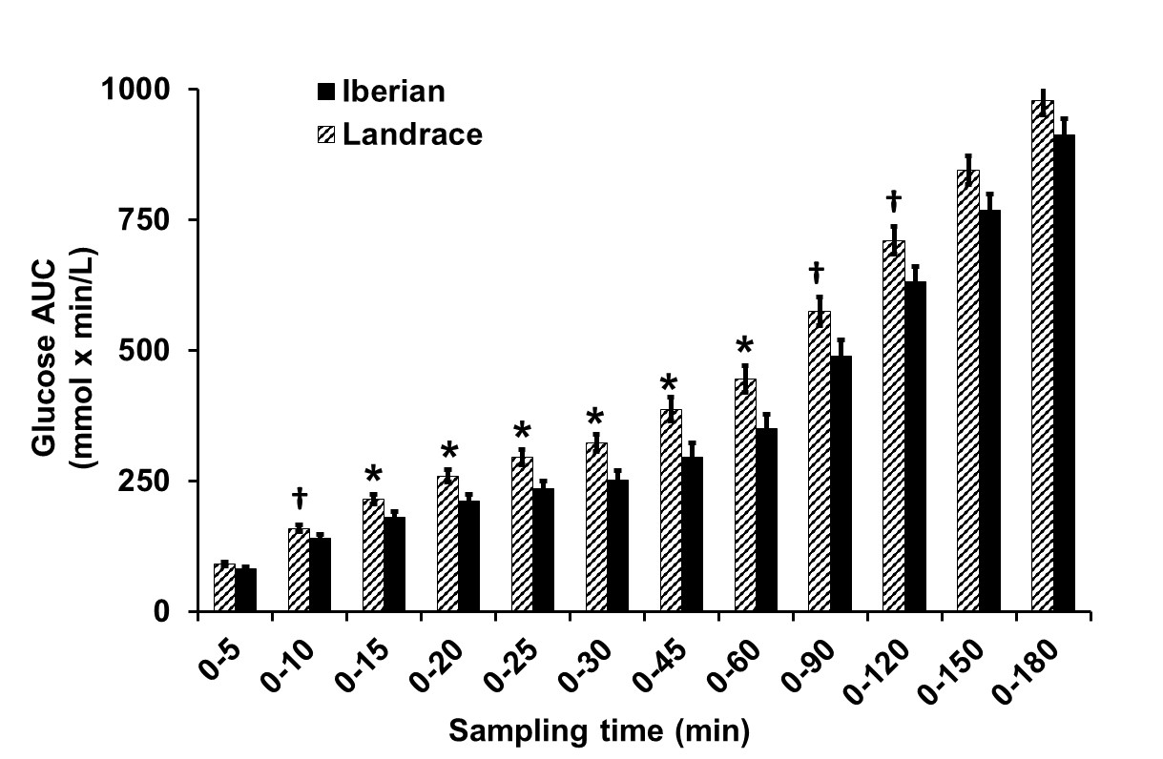
¹Differences between breeds: †0.05 < P < 0.1, *P < 0.05.

Figure 6 Area under the curve (AUC) of plasma lactate concentration during an intra-arterial glucose tolerance test (500 mg/kg BW) between minute 0 and the time points indicated in growing Iberian (n = 4) and Landrace (n = 5) pigs¹.

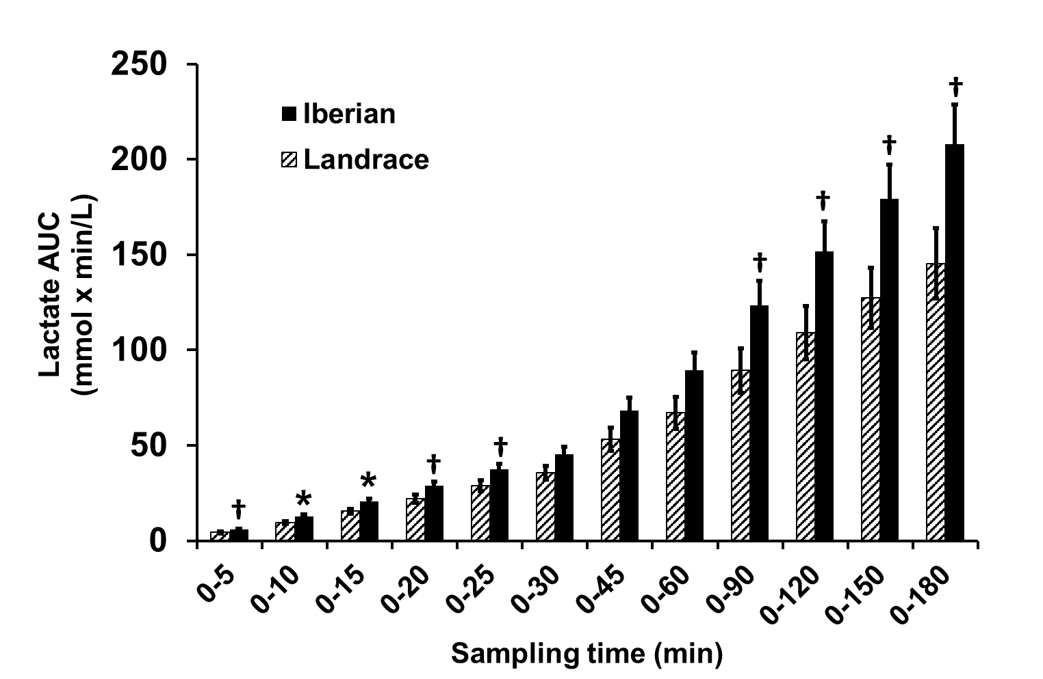
¹Differences between breeds: †0.05 < P < 0.1, *P < 0.05.

